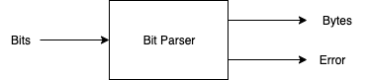
Fig. <$n:figure:Type-statck-Bits-Parsed-to-Bytes>

Bits can be parsed into bytes.

The filter for such a parser is nearly trivial: collect 8 bits, emit a byte. Emit an error if you see an EOF when you have collected fewer than 8 bits.

Even a filter as simple as that above can have more than one implementation.

Another implementation might pad 0’s onto the end of an unfinished byte, when an EOF is seen.

Or, we might pad 0’s at the front of the byte upon EOF.

Or, we might pad with trailing 1’s, or we might pad with leading 1’s.

Or, we might parse bits into ASCII and use the top bit as a parity bit.

Or, we might parse bits into EBCDIC.

Clearly, if we try to do all of the above in a single filter, the code will become unreadable and there will be option flags (TL;DR). There will be too many flags. They will need to be documented and memorized.

